Chlorophyll-a and Turbidity Sample Analysis Protocol

Equipment and supplies

- Turner AquaFluor handheld fluorometer/ turbidimeter
- Turner Rhodamine Standard (400 ppb, 60 μg/L Chla equivalency, PN 6500-120)
- AMCO 10 and 100 NTU Turbidity Standards (Thomas Scientific PN: C841E93/5)
- Turner Secondary Solid Standard (PN: 8000-952)
- Turner 12mm Test Tube Adapter (PN: 8000-932)
- VWR® 12mm Culture Tubes, Disposable, Borosilicate Glass (PN: 47729-570)
- 4 AAA batteries
- 5 mL Transfer pipettes
- KimWipes
- Nitrile gloves
- De-ionized (DI) water
- Data Transfer Cable (PN: 21-0850)

Datasheets and Software

- AquaFluor Analysis Sheet (physical paper sheet)
- AquaFluor Data Sheet Template
- AquaFluor Performance Data Sheet
- Survey Logsheet (physical paper sheet)
- Spreadsheet Interface Software (provided USB)

Additional Resources

- Turner AquaFluor Manual: https://docs.turnerdesigns.com/t2/doc/manuals/998-7210.pdf
- Turner Quick Start Guide: https://docs.turnerdesigns.com/t2/doc/manuals/998-0879.pdf
- Spreadsheet Interface Software Manual:
https://docs.turnerdesigns.com/t2/doc/instructions/998-0920.pdf

Notes

Handle culture tubes with gloves and clean with KimWipes. Carefully transfer standards and samples using transfer pipettes to limit cleaning and scratching of culture tubes. Dispose of excessively scratched tubes.

Sample Analysis

- Make sure the instrument has been calibrated and an AquaFluor Performance Data Sheet has been created for the calibration following the Chlorophyll a and Turbidity Calibration and Performance Tracking Protocol.

- Initialize logging on the AquaFluor:
  - Turn on AquaFluor.
  - Press <DATA> twice to show Logging Status.
  - If it does not say ‘Status: Logging’, Press <ENT> to enable logging.

- Prepare the AquaFluor Analysis Sheet.

  - Fill out the survey and analysis information in the grey box.
  - AquaFluor Sample ID #0-5 are pre-filled representing blank, IVCH solid standard and TRB 100 NTU readings. Record the instrument readings in the appropriate rows.
  - AquaFluor Sample ID #6 onwards represents field sample results and must be carefully filled to associate the readings with metadata. For each sample make sure to associate the AquaFluor Sample ID and GEM Sample ID. Refer to the Survey Logsheet and sample bottle labels.

- Place the 12mm culture tube adapter in the instrument sample compartment.

- Using a transfer pipette, fill a culture tube ¾ full with DI. Place within the instrument compartment.

- Run the first blank on the IVCH channel (press <READ>) and then on the TRB channel (press <A/B> to switch channels) and record the values in the AquaFluor Analysis Sheet at AquaFluor Sample ID #0 and 1.

- Repeat steps 2-3 for the second set of blanks and record the values in the AquaFluor Analysis Sheet at AquaFluor Sample ID #2 and 3.

- Remove the 12mm culture tube adapter from the instrument sample compartment.

- On the IVCH channel, take a solid standard reading (tab to the back of the instrument, press <READ>). Record the value in the AquaFluor Analysis Sheet at AquaFluor Sample ID #4.
  - Record the value in the AquaFluor Performance Data Sheet. Ensure the value is $±$ 10% of the calibration value (first row). If exceeded, troubleshoot using recommendations in the Chlorophyll a and Turbidity Calibration and Performance Tracking Protocol.

- Remove the solid standard and re-install the culture tube adapter.

- Using a transfer pipette, ¾ fill a culture tube with the 100 NTU turbidity standard and place it in the instrument.

- Switch to the TRB channel (press <A/B>) and take a 100 NTU standard reading. Record the value in the AquaFluor Analysis Sheet at AquaFluor Sample ID #5.
  - Record the value in the AquaFluor Performance Data Sheet. Ensure the value is $±$ 10% of the calibration value. If exceeded, troubleshoot using recommendations in the Chlorophyll a and Turbidity Calibration and Performance Tracking Protocol.

- Remove the culture tube.

- Cross check that the sample bottle label and Survey Logsheet align with the AquaFluor Analysis Sheet.

- Gently invert the sample bottle 3x.

- Using a transfer pipette, ¾ fill a culture tube with sample water from the sample bottle.

- Place the culture tube in the instrument (work in subdued light and limit light exposure - the culture tubes do not allow for the instrument lid to be closed)

- Take an IVCH reading and record it in the correct AquaFluor Analysis Sheet row.

- Leave the culture tube in the instrument and press <A/B> to switch to the TRB channel.

- Take an TRB reading and record it in the appropriate AquaFluor Analysis Sheet row.

- Remove the culture tube.

- Repeat steps 10-17 until the triplicate readings of both channels are complete for the sample.

- Repeat steps 10-17 for the next sample starting with the appropriate Sampling Event ID (e.g. 1_14). Refer to the Survey Logsheet.

Data download and management

Must have excel and the Spreadsheet Interface Software downloaded (downloaded from USB key in kit)

- Connect AquaFluor to the computer with the provided cord. (Cable - Data Logger Handheld P/N 21-0850). Ensure the instrument end is plugged all the way in.

- Open the Spreadsheet software, select the correct COM port and click ‘Start’. COM and MS Excel boxes should both turn green.

- Turn on AquaFluor.

- Press <DATA> x3.

- Press <ENT> x5.

- Turn off AquaFluor, save the Excel ‘spreadsheet.xlsx’ and then press ‘close’ on spreadsheet software.

- Download (or open a copy of) the AquaFluor Data Sheet Template, and save as: {YYYY-MM_DD}_aquafluor_processed.xlsx

- Fill in {YYYY-MM_DD}_aquafluor_processed.xlsx using info from the AquaFluor Analysis Sheet and from the Spreadsheet Interface Software download ‘spreadsheet.xlsx’.
  - Note: Quality Flag follows these levels:

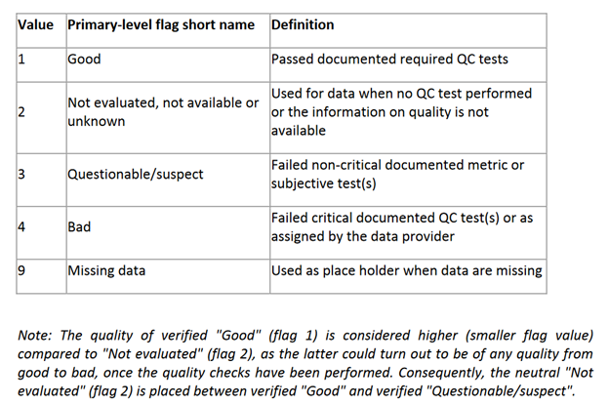

- Save a .csv version of the {YYYY-MM_DD}_aquafluor_processed sheet and save it as {YYYY-MM_DD}_aquafluor_final.csv

- Navigate to the /data/{YYYY-MM-DD}_survey/Aquafluor/ folder of the Github repository, and upload {YYYY-MM_DD}_aquafluor_processed.xlsx and {YYYY-MM_DD}_aquafluor_final.csv

- Take a photo of the AquaFluor Analysis Sheet(s) and upload to the same folder, with the name {YYYY-MM_DD}_aquafluor_raw.jpeg.

